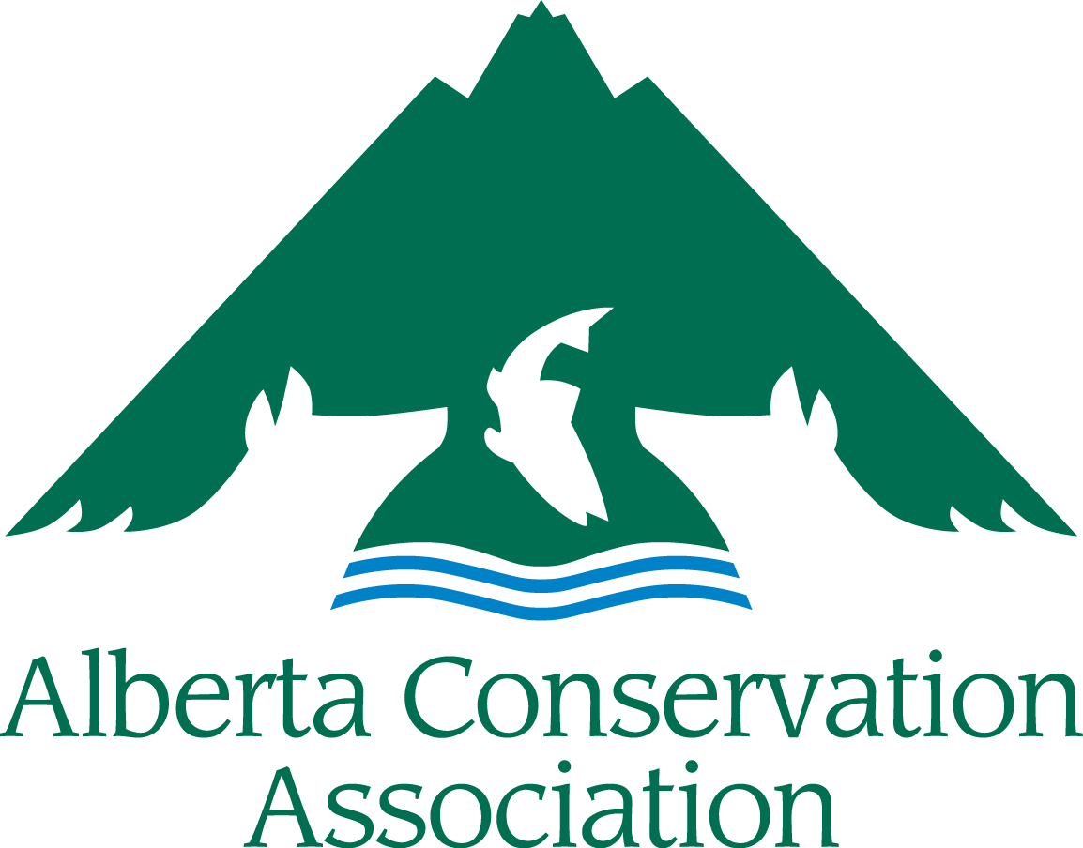

Minister’s Special Licence

Resident Draw Grants

Application Form

2025 – 2026

**BEFORE YOU SUBMIT, PLEASE MAKE SURE:**

* You read the *Minister’s Special Licence Resident Draw Grants* (MSLRDG) *Submission Guidelines* for 2025-26.
* Your application is complete. Incomplete applications will be returned to the applicant. All sections must be filled in.
* Your application is NOT longer than the 8-page limit (excluding the cover page). Any pages over the limit will be redacted before going to the Adjudication Committee.
* Your application is a legible font size (i.e., nothing smaller than Arial 10).

**Please submit your digital application to** [**grants.msl@ab-conservation.com**](mailto:amy.mackinven@ab-conservation.com)

**Applications accepted from November 1, 2024, to December 10, 2024**

**(NO later than 16:30 MST on Tuesday, December 10, 2024)**

***IMPORTANT NOTICE: upon receiving your application, we will send you an acknowledgment receipt by e-mail or telephone within five business days. It is your responsibility to contact the ACA Grants Coordinator if you have not received acknowledgement of receipt, as the application may not have been received in good order.***

****APPLICANT INFORMATION

|  |  |
| --- | --- |
| Principal Applicant’s Name |  |
| Organization |  |
| Mailing Address |  |
| Email Address |  |
| Telephone Number |  |
| Project Manager/Co-applicant(s)  (if different than applicant) |  |
| Business Number (if applicable) |  |

**PROJECT INFORMATION**

|  |  |  |  |  |
| --- | --- | --- | --- | --- |
| Project Title |  | | | |
| Project Location |  | | | |
| Project Duration | Start date dd/mm/yyyy |  | End date dd/mm/yyyy |  |
| Project Summary (Please include a brief description of your project containing the *objectives*, *activities,* and *project deliverables*; maximum 250 words) | | | | |
| Amount requested from MSLRDG  (in Canadian dollars) | |  | | |

Has this project received financial or administrative support from Minister’s Special Licence (MSL) grants in the past? If yes, list the grants and highlight the results of the work previously supported by the MSL. How does the present funding request build on that work?

|  |
| --- |
|  |

Long Term Requirements (Is the project ongoing? Does this project require subsequent funding to reach project objectives? If applicable, explain how this project will continue after being funded by MSLRDG.)

|  |
| --- |
|  |

**PROJECT DESCRIPTION**

Project Background/Project Rationale

|  |
| --- |
|  |

Project Objectives (Clearly state the project’s specific objectives, i.e., what is your project trying to achieve?)

|  |
| --- |
|  |

Project Activities (How and when are you going to achieve the above objectives?)

|  |
| --- |
|  |

Deliverables (List anticipated products and completion dates resulting from your project, including reports, videos, publications, structures built, promotional material, number of events with dates and locations, number of educated participants/campers, number of people reached, kilometres of wildlife-friendly fencing, hectares sustainably managed, etc.)

|  |
| --- |
|  |

List Project Partners (Project Partners must be aware they are listed here and be involved with this specific project. Do not include organization partners if they are not involved with the project.)

|  |
| --- |
|  |
|  |
|  |
|  |

**LINK WITH THE MSLRDG FUNDING PRORITIES**

Select all the Funding Priorities, as outlined in *Section 4 of the Submission Guidelines*, that your project addresses and discuss in the text box below how your proposed project helps further the Funding Priorities.

Funding Priority A  Funding Priority D  Funding Priority G

Funding Priority B  Funding Priority E  Funding Priority H

Funding Priority C  Funding Priority F

Discuss how this project meets the Funding Priorities selected.

|  |
| --- |
|  |

Does your project focus on any of the following species? Select all that apply:

|  |  |  |
| --- | --- | --- |
| Bighorn sheep | Mule deer | Mountain goat |
| Elk | White-tailed deer | Pronghorn |
| Moose | Cougar | Turkey |

Explain how your project will benefit hunters in Alberta (maximum of 250 words)

|  |
| --- |
|  |

**BUDGET**

|  |  |  |  |  |  |
| --- | --- | --- | --- | --- | --- |
| **Category** | **Description** | **Amount Requested from MSLRDG** | **Confirmed Partner Funding** | **In Kind Support** | **Total** |
| **Materials & Supplies** |  |  |  |  |  |
| **Equipment** |  |  |  |  |  |
| **Salaries & Wages** |  |  |  |  |  |
| **Contract Services** |  |  |  |  |  |
| **Travel** |  |  |  |  |  |
| **Honorariums** |  |  |  |  |  |
| **Other** |  |  |  |  |  |
| TOTAL COSTS | |  |  |  |  |

Please Note: MSLRDG do not cover overhead costs. See *Submission Guidelines Section 4 Budget Notes* for more information.

**PROJECT BUDGET COMMENTARY**

**BUDGET COMMENTARY:**

Provide breakdown the budget requested from the MSLRDG, including salary costs/honoraria (number of staff, rate, etc.), equipment (unit cost, etc), and any other details that may assist with the evaluation of your budget. Do not send quotes.

|  |
| --- |
|  |

Summarize any Partner Funding Dollars(Indicate if the partner funds are confirmed or pending approval. Confirmed partner funding should be listed in the budget. If there is no partner funding, explain why not.):

|  |
| --- |
|  |

**Summarize any Public Involvement in the Project** (Such as in-kind support, number of volunteers, etc.):

|  |
| --- |
|  |

**PROJECT COMMUNICATION**

How will MSLRDG be recognized for its funding support?

|  |
| --- |
|  |

How will you share the results of the project with others?

|  |
| --- |
|  |

**LICENCES, APPROVALS & INSURANCE**

As principal applicant, I have ensured all the proper licences, insurance, permits, and approvals required to carry out the project are in place, and I have complied with all the requirements of my organization.

YES  NO

If you ticked NO above, please explain how will you obtain them in time to carry out this project?

|  |
| --- |
|  |

Please Note: *Successful applicants will be expected to follow the ACA Cooperative Project Agreement. In applying to the MSLRDG program, you are agreeing to use ACA’s Cooperative Project Agreement. A copy of the Cooperative Project Agreement can be found on Appendix 2 of the MSLRDG Submission Guidelines document.*